Name: Muhammad Nauman Alam Khan

Student ID: 3048507

Website URL: <https://naumankhan.netlify.app/>

Screenshot of the actual webpage:

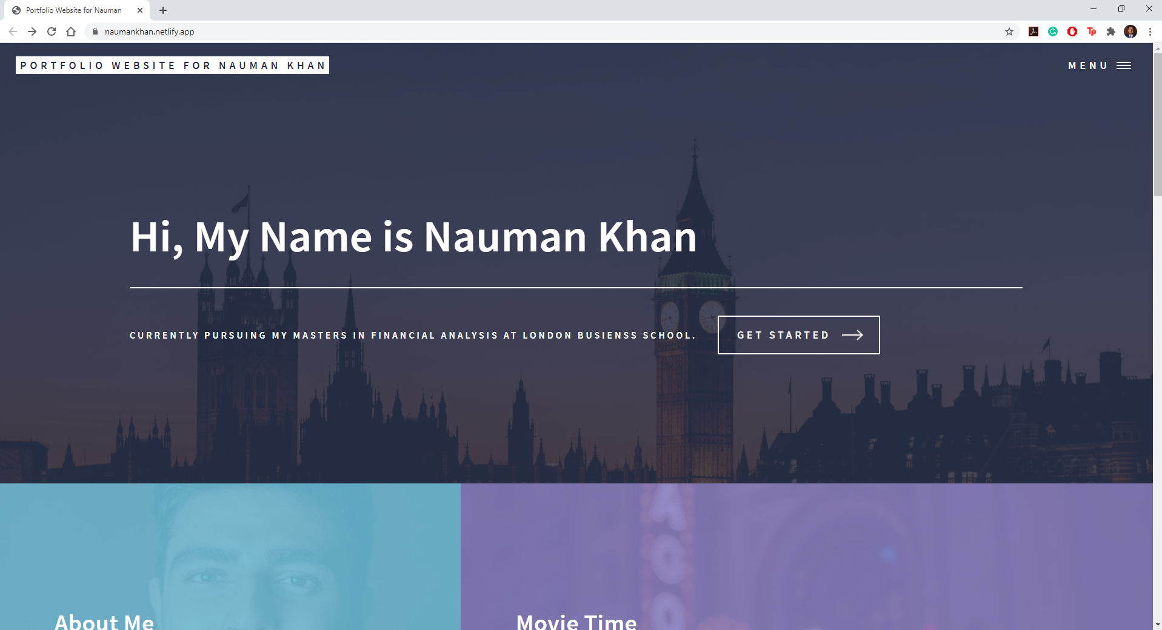

Screenshot of github repo:

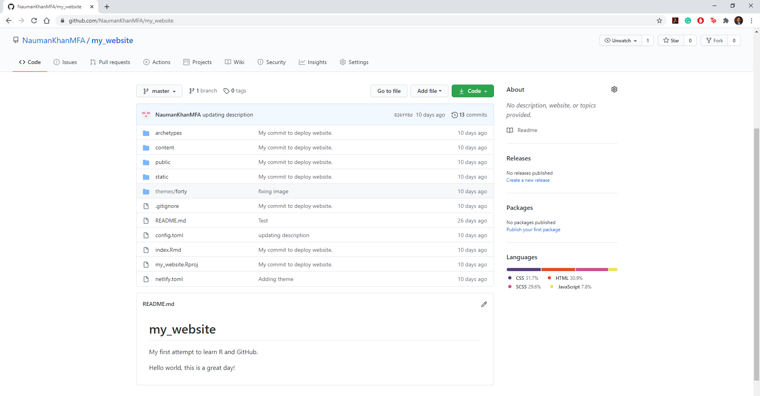

Screenshot of netlify account:

